Registration Retrieval

Problem:
A Google Form was used for people to sign up for lunch during the rummage sale. The form collects names, items ordered, and payment information. During lunch distribution, coworkers had to manually search the spreadsheet to verify each person's order as they arrived. Once the lunch was distributed, they had to cross out the record to avoid duplicate pickups. This process was highly time-consuming and created a significant bottleneck.

Proposed Solution:
An application or web page where coworkers can quickly locate an order and update the record without having to look through the spreadsheet manually.

Option 1:
- Use the Google Form as the data source.
- When a person comes to get lunch, they must provide their phone number.
- The coworker enters the phone number, retrieves the order, and confirms it with the person.
- Once the order is confirmed, the record is marked. If the same phone number is entered again, the system will alert the coworker that the lunch has already been picked up.

Option 2:
- More efficient
- When a person finishes the online registration, a QR code is sent to them (a custom registration page may need to be built if Google Forms does not support this feature).
- When the person comes to get lunch, the coworker scans the QR code to instantly retrieve the order.
- The record is marked in real time, so if another person attempts to use the same QR code, it will trigger a warning.

We are open to other suggestions. The main goal is to make the process more efficient and the software should be easy to use and flexible enough to extend to other types of registration, not just for lunch ordering.

Statement of Work (08/24/2026)
- Event Registration
- Provide an online google form for the event. The form will have the following basic fields:
Name, phone number, email address, check in status, food type and order number and unique generated random number. Some basic rules and gramma check if needed to avoid invalid entries.
- User registers to the form and fill out the information. When user completes the registration, the form sends an acknowledgement to both email and phone number with a QR code. The user will use the QR code to grant admission to a meeting or a conference.
- Church orders the food based on the registration list. We will add a column to ensure food is ordered for each registrant.
- Admission to Conference or Food Pick up
- The attendee appears at the front desk. A barcode scan acknowledges the attendee based on the Google Form (or database). It updates the Google form with check in flag.
- At lunch time, Cafeteria scans the attendee’s barcode and check if the food order is in place. If it does, the pickup flag is set. The attendee can pick up the right food.
- If the user does not order any food, he can work on the registration page and update the food order. Then cafeteria scan the attendee’s barcode to finish the food pick up.

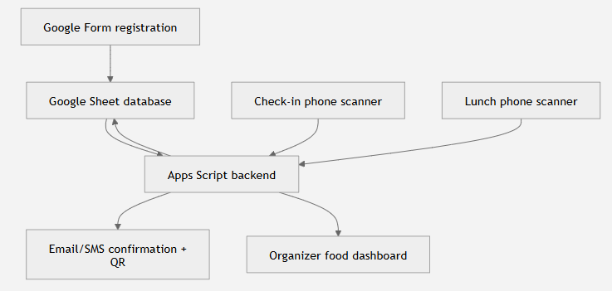
flowchart TD
A["Google Form registration"] --> B["Google Sheet database"]
B --> C["Apps Script backend"]
C --> D["Email/SMS confirmation + QR"]
C --> E["Organizer food dashboard"]
F["Check-in phone scanner"] --> C
G["Lunch phone scanner"] --> C
C --> B

Registration record in the database:
# | Field | Purpose
1 | Registration ID | Human-readable reference number
2 | QR token | Random, unguessable identifier encoded in the QR
3 | Name | Attendee information
4 | Email | Attendee information
5 | Phone | Attendee information
6 | Event ID | Supports multiple church activities
7 | Meal selection | Requested meal type or “no meal”
8 | Registration status | Submitted, confirmed, canceled, waitlisted
9 | Meal ordered | Organizer confirms the meal was included in the final order
10 | Event check-in time | Set by the check-in scanner
11 | Meal redeemed time | Set by the lunch scanner
12 | Operator/device | Audit trail for each scan
13 | Periodic notification | Notify the user with pre-recorded message before the event
14 | Cancellation | Notify the user with cancellation message

Use Google Apps Script MVP (Minimized Viable Product): a functional, low-cost prototype designed to validate a business idea and gather user feedback before investing heavily in custom software development. By leveraging the built-in storage of Google Sheets or Forms and automating processes via JavaScript, startups and developers can roll out fully functional application workflows with zero infrastructure costs.

Instead of hiring expensive software engineers to construct a back-end, database, and front-end interface from scratch, founders combine native Google Workspace capabilities:
- The Database (Google Sheets): Acts as the central system of record to log, organize, and store user or operational data.
- The Frontend UI (Google Forms or HTML Service): Forms or native document interfaces collect data from users. Advanced developers use the HTML Service in Apps Script to render completely custom web applications.
- The Automation Engine (Apps Script): Processes incoming form entries, triggers automated emails via Gmail, dynamically generates custom PDF documents, or links button clicks directly to internal data flows.
- Third-Party Integrations: Connects the MVP infrastructure to external payment processors, texting platforms, or CRM tools using external APIs or webhooks.

Milestone 1: (08/25-09/01)
- Create a standalone Apps Script project. We will create Google Apps Script (.gs) which can run on the Google server. .gs is sever-side code file in Google Apps Script—which is a proprietary coding language created by Google that is based on standard JavaScript.
- Copy the required source files into it
- Run setupApplication()
- Verify that the Google Form and spreadsheet database were created
- Customize the event and food choices

Milestone 2: (09/02-09/08)
- Deploy the QR-receipt web application
- Activate the Google Form
- Complete one registration from your phone. We will test email first; SMS and scanning can follow after this works.

